FOREST/ANIMALS, GAME
Recognizing excrements of animals

- Try to recognize animal’s excrements and compound the right animal and the right excrement together.

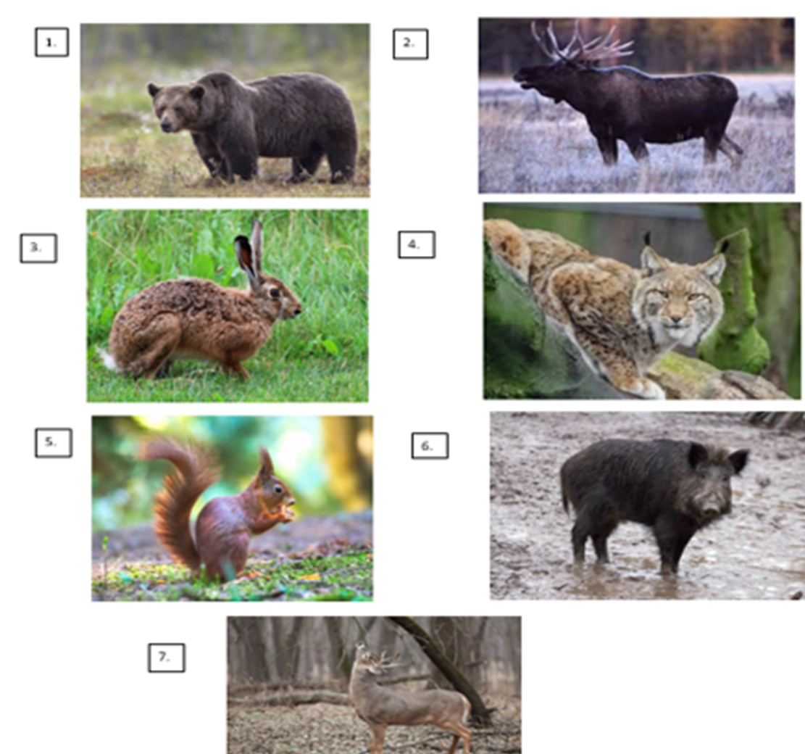

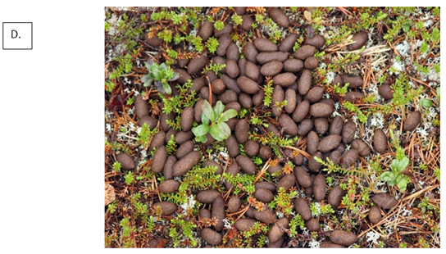

FOREST/ANIMALS, GAME
Eläinten jätösten tunnistaminen/ Recognizing excrements of animals

Ohjaajan apu/ Advisor’s help
VASTAUKSET/ ANSWERS

1 – C 2 – D
3 – B 4 – A
5 – [] 6 – []
7 – []
