SUSTAINABLE DEVELOPMENT
Finnish cottage culture
Answer the questions in Finnish, German and English.

- What is the most ecological way to build a cottage?
- Tell something about Finnish cottage culture. (at least 5 things)
- What magic thing is used in the sauna for health purposes and what you can foresee with that in the midsummer night?
- Recognize the houses from the pictures and give them their own names. Take photos of them.
- Which way is more ecological way to heat sauna with electricity or wood?
- What is the most ecological way to heat cottage?
- Which Finnish holiday is usually spent at the cottage?
- Find information about Alvettula bridge or some other historical bridge.
- Build a small cottage of natural antimony. ( branches, stones, leafs) NB! Don’t harm nature, use only material which is already on the ground.
- Build a cone cow. NB! Don’t harm nature, use only material which is already on the ground.
- Build a bark boat and send it to waters if you can. NB! Don’t harm nature, use only material which is already on the ground.

SUSTAINABLE DEVELOPMENT
Finnish cottage culture
Advisor´s help
ANSWERS
- Logs and wood
- Sauna, swimming, sauna beer, barbecuing, campfire, relaxation, fishing, boating, various games(card games, ¨mölkky¨, dartboard)
- Saunavihta
- a) granary, b) ground cellar, c) barn, d) outhouse, e) milk platform, f) stables
- Electricity
- With electricity, because heating with wood sets carbon monoxide to the air
- Midsummer
- -

KESTÄVÄ KEHITYS/ SUSTAINABLE DEVELOPMENT
Suomalainen mökkikulttuuri/ Finnish cottage culture

a) 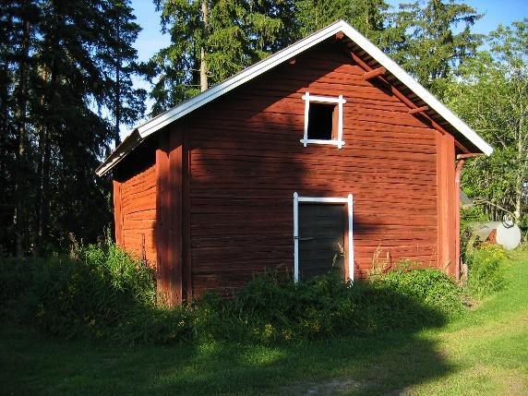 b) 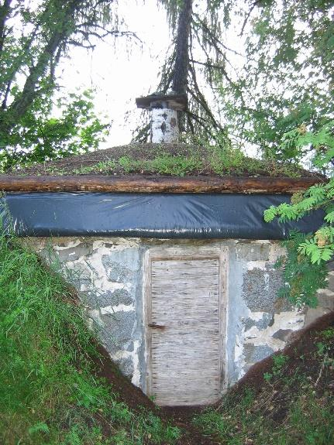

c) 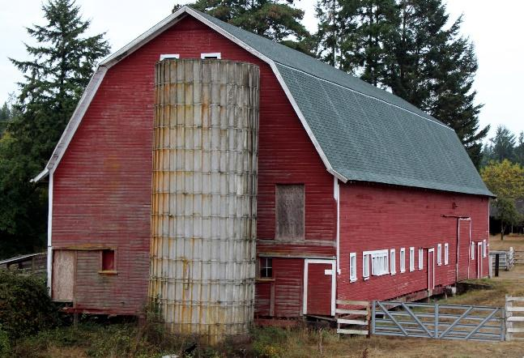 d) 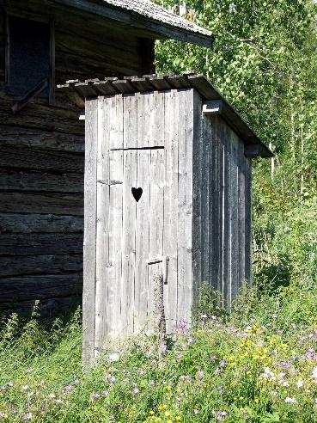

e) 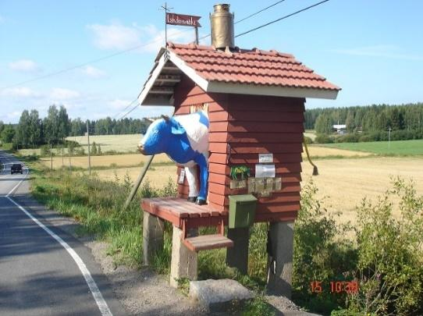 f) 